产 品 规 格 书
Product Specification Sheet

TOP-BIDI-XFP-ZR-80
RoHS Compliant 10Gb/s XFP 1490/1550nm BIDI 80km Optical Transceiver

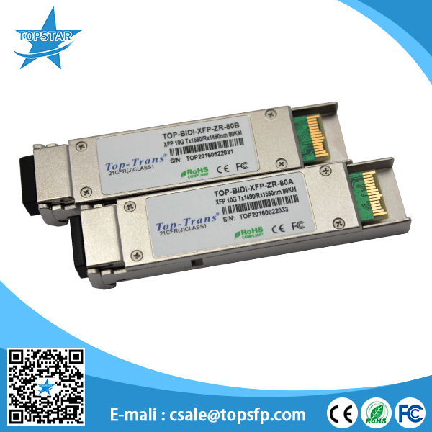

PRODUCT FEATURES
- XFP MSA package with single LC connector
- Typical bidi 1490/1550nm and 1550nm/1490nm for commission
- APD receiver for high sensitivity
- Hot pluggable
- Support 9.95Gb/s to 11.1Gb/s bit rates
- Digital Diagnostic Monitor Interface
- Very low EMI and excellent ESD protection
- +3.3V single power supply
- Below <1.5w power consumption
- operating temperature range 0°C to 70°C
- No reference clock requirement

APPLICATIONS
- 10GBASE-BX 10.3125Gb/s Ethernet
- 10GBASE-BX 9.953Gb/s Ethernet
- SONET OC-192 &SDH STM I-64.1

STANDARD
- XFP MSA Compliant
- SFF-8472 reversion 9.5 compliant
- IEEE802.3-2005 compliant
- Telcordia GR-468-CORE compliant
- FCC 47 CFR Part 15,Class B compliant
- FDA 21 CFR 1040.10 and 1040.11,class1 compliant
- RoHS compliant

PRODUCT DESCRIPTIONS
TOPSTAR's TOP-BIDI-XFP-ZR-80 transceivers are designed for 10G Ethernet 10G BASE-LR/LW per 802.3ae and 10G SOI OC-192/SDH STM-64, and it can support data-rate from 9.953Gb/s to 11.1Gb/s. Digital diagnostics are avail-able via I2C interface as specified in the XFP MSA.
The transceiver designs are optimized for high performance and cost effective to supply customers the best solutions for data-com and telecom applications.

ABSOLUTE MAXIMUM RATINGS
Parameter | Symbol | Min. | Max. | Unit | Note
Supply Voltage | Vcc | -0.5 | 4.0 | V
Storage Temperature |  | -40 | 85 | °C
Relative Humidity |  |  | 85 | %
Note: Stress in excess of the maximum absolute ratings can cause permanent damage to the module

GERERAL OPERATING CHARACTERISTICS
Parameter |  | Symbol | Min. | Typ | Max. | Unit | Note
Data Rate | Ethernet |  |  | 10.3125 |  | Gb/s
Data Rate | Fiber Channel |  |  | 9.953 |  | Gb/s
Supply Voltage |  | Vcc | 3.14 | 3.3 | 3.46 | V
Supply Current |  | Icc |  |  | 450 | mA
Operating Case Temp. |  | Tc | 0 |  | 70 | °C

ELECTRICAL INPUT/OUTPUT CHARACTERISTICS
- Transmitter
Parameter |  | Symbol | Min. | Typ | Max. | Unit | Note
Diff. input voltage swing |  |  | 120 |  | 820 | mVpp | 1
Tx Disable input | H | VIH | 2.0 |  | Vcc+0.3 | V
Tx Disable input | L | VIL | 0 |  | 0.8 | V
Tx Fault output | H | VOH | 2.0 |  | Vcc+0.3 | V | 2
Tx Fault output | L | VOL | 0 |  | 0.8 | V | 2
Input Diff. Impedance |  | Zin |  | 100 |  | Ω

- Receiver
Parameter |  | Symbol | Min. | Typ | Max. | Unit | Note
Diff. output voltage swing |  |  | 340 | 650 | 800 | mVpp | 3
Rx LOS Output | H | VOH | 2.0 |  | Vcc+0.3 | V | 2
Rx LOS Output | L | VOL | 0 |  | 0.8 |  | 2
Note 1) TD+/- are internally AC coupled with 100Ω differential termination inside the module.
Note 2) Tx Fault and Rx LOS are open collector outputs, which should be pulled up with 4.7k to 10kΩ resistors on the host board. Pull up voltage between 2.0V and Vcc+0.3V.
Note 3) RD+/- outputs are internally AC coupled, and should be terminated with 100Ω (differential) at the user SERDES.

OPTICAL CHARACTERISTICS
- Transmitter (10.3125Gb/s)
Parameter | Symbol | Min. | Typ | Max. | Unit | Note
Operating Wavelength | T4/R5 | 1480 | 1490 | 1500 | nm | 1
Operating Wavelength | T5/R4 | 1540 | 1550 | 1560 | nm | 1
Ave. output power (Enabled) | Po | +1 |  | +6 | dBm | 2
Extinction Ratio | ER | 5 |  |  | dB | 2
RMS spectral width | Δλ |  |  | 1 | nm
Rise/Fall time (20%~80%) | Tr/Tf |  |  | 50 | ps | 3
Optical modulation amplitude | OMA | -4.8 |  |  | dBm
Dispersion penalty |  |  |  | 3 | dB
Output Optical Eye | IEEE 802.3-2005 Compliant

- Receiver (10.3125Gb/s)
Parameter | Symbol | Min. | Typ | Max. | Unit | Note
Operating Wavelength | T4/R5 | 1540 | 1550 | 1560 | nm | 1
Operating Wavelength | T5/R4 | 1480 | 1490 | 1500 | nm | 1
Sensitivity | Psen |  |  | -22 | dBm | 4
Min. overload | Pimax | -7 |  |  | dBm
LOS Assert | Pa | -40 |  |  | dBm
LOS De-assert | Pd |  |  | -22 | dBm
LOS Hysteresis | Pd-Pa | 0.5 |  | 4 | dB

Note 1) 1470nm~1610nm transmitter, minimum interval 60nm.
Note 2) Measured at 10.3125b/s with PRBS 2³¹ – 1 NRZ test pattern.
Note 3)20%~80%
Note 4)Under the ER worst case, measured at 10.3125 Gb/s with PRBS 2³¹ - 1 NRZ test pattern for BER < 1x10⁻¹²

SERIAL INTERFACE FOR ID AND DDM
The XFP modules implement the 2-wire serial communication protocol as defined in the XFP MSA.
The serial ID information of the XFP modules and Digital Diagnostic Monitor parameters can be accessed through the I2C interface at address A0h and A2h. The memory is mapped in Table 1. Detailed ID information(A0h) And the DDM specification(A2h) . For more details of the memory map and byte definitions, please refer to the SFF-8472 (Rev 9.3, Aug. 2002), “Digital Diagnostic Monitoring Interface for Optical Transceivers”.
The DDM parameters have been internally calibrated.

Table 1. Digital Diagnostic Memory Map (Specific Data Field Descriptions)

PIN DEFINITIONS AND FUNCTIONS

PIN # | Name | Function | Name/Description | Notes
1 |  | GND | Module Ground | 1
2 |  | VEE5 | Optional -5.2V Power Supply (Not required)
3 | LVTTL-I | MOD_DESEL | Module De-select; When held low allows the module to respond to 2-wire serial interface
4 | LVTTL-O | INTb | Interrupt; Indicates presence of an important condition which can be read via the 2-wire serial interface | 2
5 | LVTTL-I | TX_DIS | Transmitter Disable; Turns off transmitter laser output
6 |  | VCC5 | +5V Power Supply (Not required)
7 |  | GND | Module Ground | 1
8 |  | VCC3 | +3.3V Power Supply
9 |  | VCC3 | +3.3V Power Supply
10 | LVTTL-I/O | SCL | 2-Wire Serial Interface Clock | 2
11 | LVTTL-I/O | SDA | 2-Wire Serial Interface Data Line | 2
12 | LVTTL-O | MOD_ Abs | Indicates Module is not present. Grounded in the Module | 2
13 | LVTTL-O | MOD_NR | Module Not Ready; Indicating Module Operational Fault | 2
14 | LVTTL-O | RX_LOS | Receiver Loss Of Signal Indicator | 2
15 |  | GND | Module Ground | 1
16 |  | GND | Module Ground | 1
17 | CML-O | RDN | Receiver Inverted Data Output
18 | CML-O | RDP | Receiver Non-Inverted Data Output
19 |  | GND | Module Ground | 1
20 |  | VCC2 | +1.8V Power Supply (Not required). | 3
21 | LVTTL-I | P_DOWN/RST | Power down; When high, requires the module to limit power consumption to 1.5W or below. 2-Wire serial interface must be functional in the low power mode.
21 | LVTTL-I | P_DOWN/RST | Reset; The falling edge initiates a complete reset of the module including the2-wire serial interface, equivalent to a power cycle.
22 |  | VCC2 | +1.8V Power Supply (Not required) | 3
23 |  | GND | Module Ground | 1
24 | PECL-I | REFCLKP | Not used, internally terminated to 50ohm (100ohm diff). | 4
25 | PECL-I | REFCLKN | Not used, internally terminated to 50ohm (100ohm diff). | 4
26 |  | GND | Module Ground | 1
27 |  | GND | Module Ground | 1
28 | CML-I | TDN | Transmitter Inverted Data Input
29 | CML-I | TDP | Transmitter Non-Inverted Data Input
30 |  | GND | Module Ground | 1
Note:
1. Module ground pins GND are isolated from the module case and chassis ground within the module.
2. Open collector; Shall be pulled up with 4.7K-10Kohms to a voltage between 3.15V and 3.6V on the host board.
3. The pins are open within module.
4. Reference Clock is not required.

TYPICAL INTERFACE CIRCUIT
PACKAGE DIMENSIONS

ORDERING INFORMATION
Part Number | Description
TOP-BIDI-XFP-ZR-80AD | XFP BiDi, CWDM TX1490nm/RX1550nm,10.3125Gbps, 80KM,0~70℃, with DDM
TOP-BIDI-XFP-ZR-80BD | XFP BiDi, CWDM TX1550nm/RX1490nm,10.3125Gbps, 80KM,0~70℃, with DDM
……

Topstar Technology Industrial Co., Ltd
Add: F5, Rongcheng Building, 28 Yayuan Road Wuhe Community, BanTian Street, Shenzhen, China

Tel: +86 755 8255 2969 Email: lisa@topsfp.com
Skype: lisalin6565 WhatsApp: +86 13798265065
WeChat: 251081707
Facebook and Linked in: Topstar Technology Industrial Co., Ltd



